#include <stdio.h>
int main()
{
int arr[5];
int i;
printf("Enter 5 elements:\n");
for(i = 0; i < 5; i++) {
printf("Element %d: ", i+1);
scanf("%d", &arr[i]);
}
printf("\nThe elements in the array are:\n");
for(i = 0; i < 5; i++) {
printf("%d ", arr[i]);
}
return 0;

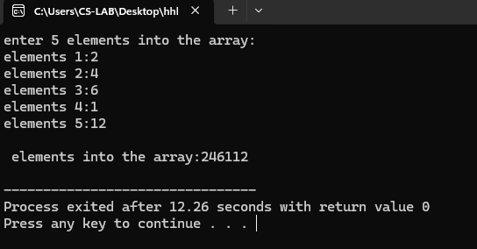
#include <stdio.h>

int main()
{
int n, i, sum = 0;
printf("Enter number of elements: ");
scanf("%d", &n);

int arr[n];
printf("Enter %d integers:\n", n);
for(i = 0; i < n; i++) {
scanf("%d", &arr[i]);
sum += arr[i];
}
printf("Sum of %d integers = %d\n", n, sum);

return 0;
}

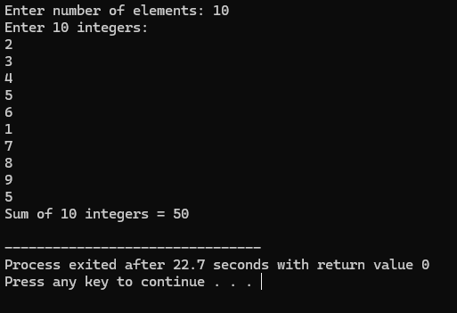

#include <stdio.h>

int main()
{
int n, i, key, found = 0;
int arr[100];
printf("Enter the number of elements: ");
scanf("%d", &n);
printf("Enter %d elements:\n", n);
for (i = 0; i < n; i++) {
scanf("%d", &arr[i]);
}
printf("Enter the element to search: ");
scanf("%d", &key);
for (i = 0; i < n; i++) {
if (arr[i] == key) {
printf("Element %d found at position %d.\n", key, i + 1);
found = 1;
break;
}
}

if (!found) {
printf("Element %d not found in the array.\n", key);
}

return 0;
}

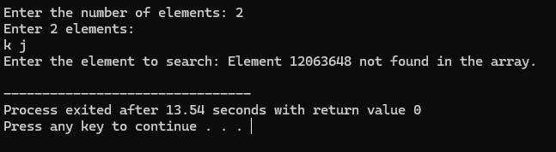
#include <stdio.h>
int main()
{
int n, i;
int arr[100];
int largest, smallest;
printf("Enter the number of elements: ");
scanf("%d", &n);
printf("Enter %d elements:\n", n);
for (i = 0; i < n; i++) {
scanf("%d", &arr[i]);
}
largest = arr[0];
smallest = arr[0];
for (i = 1; i < n; i++) {
if (arr[i] > largest) {
largest = arr[i];
}
if (arr[i] < smallest) {
smallest = arr[i];
}
}
printf("Largest element = %d\n", largest);
printf("Smallest element = %d\n", smallest);

return 0;
}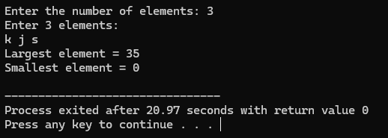

#include <stdio.h>
int main()
{
int n, i, j, temp;
int arr[100];
printf("Enter the number of elements: ");
scanf("%d", &n);
printf("Enter %d elements:\n", n);
for (i = 0; i < n; i++) {
scanf("%d", &arr[i]);
}
for (i = 0; i < n - 1; i++) {
for (j = 0; j < n - i - 1; j++) {
if (arr[j] > arr[j + 1]) {
// Swap elements
temp = arr[j];
arr[j] = arr[j + 1];
arr[j + 1] = temp;
}
}
}
printf("Array in ascending order:\n");
for (i = 0; i < n; i++) {
printf("%d ", arr[i]);
}
printf("\n");

return 0;
}

